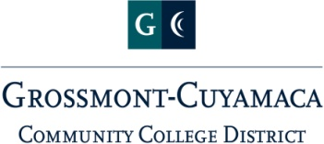
Human Resources Advisory Council
Agenda
Wednesday, March 22, 2023
1:30 – 3:00 pm

Zoom Meeting

Aimee Gallagher – Chair-Human Resources
Bernadette Black – Confidential Staff Rep
Cindy Hall – Classified Senate Rep (GC)
Colleen Parsons – CSEA Rep
Craig Leedham – Conf. Administrators Rep
Sharon Sampson – EEO Site Lead
Katie Cabral – Classified Senate Rep (CC)
Manuel Mancillas-Gomez – Academic Senate Rep (CC)
Nicole Conklin – AA Rep
Pearl Lopez – Academic Senate Rep (GC)
Moriah Gonzalez-Meeks – Advisory Role
TBD – Title IX and EEO Officer
Karen Marrujo – EEO – Site Lead
Nashona Andrade – Director of HR
Nicole Salgado – VPAS (GC)

Topic
AP 7130 – Compensation (final read)
BP 7335 – Health Examinations (first read)
EEO Plan
Standing Item – Equity in Hiring Taskforce
Group Updates
Next Meeting – Wednesday, April 26 1:30-3:00 zoom

